Solder the *Waveshare 20646 FT232 USB UART Board (Type C)*. Remove the jumper marked on the picture

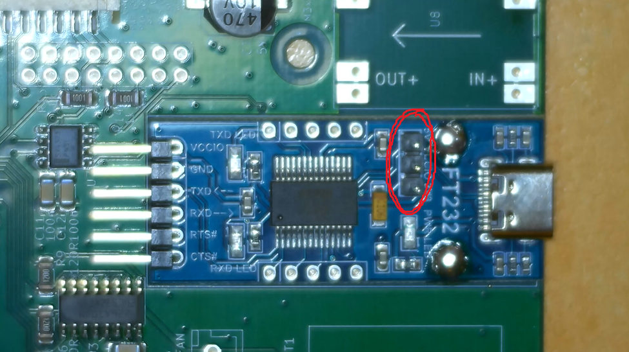

Only solder joints marked on the picture need to be connected. Two 5-pin rows can be skipped.

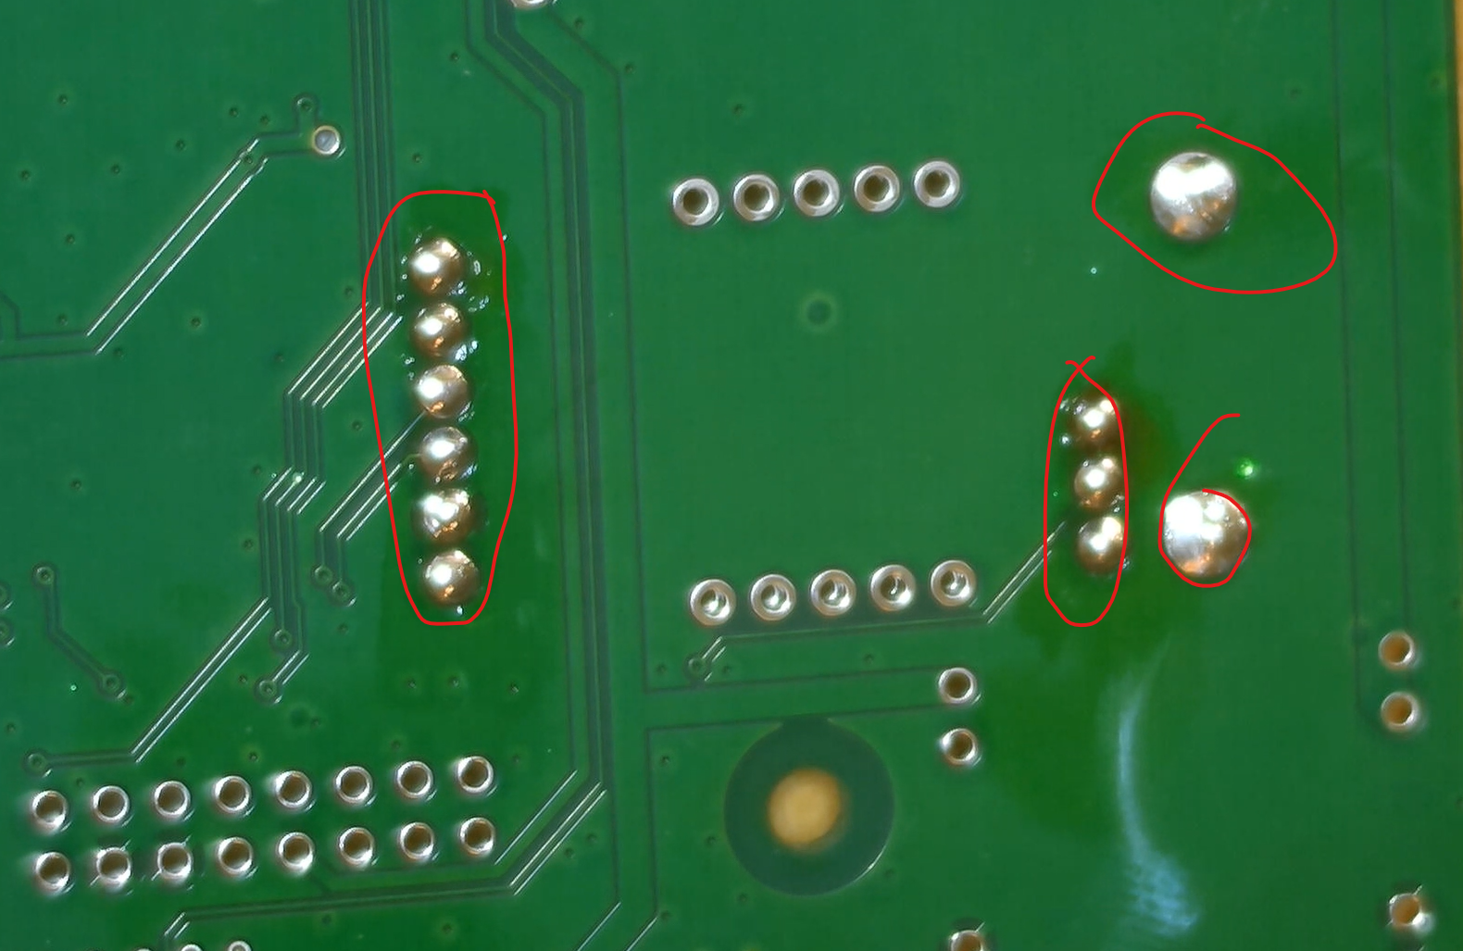

**DCDC converter Variant A (older board)**

Solder the DC-DC converter. Place the 2-pin headers, then the PCB, solder everything **afterwards**.

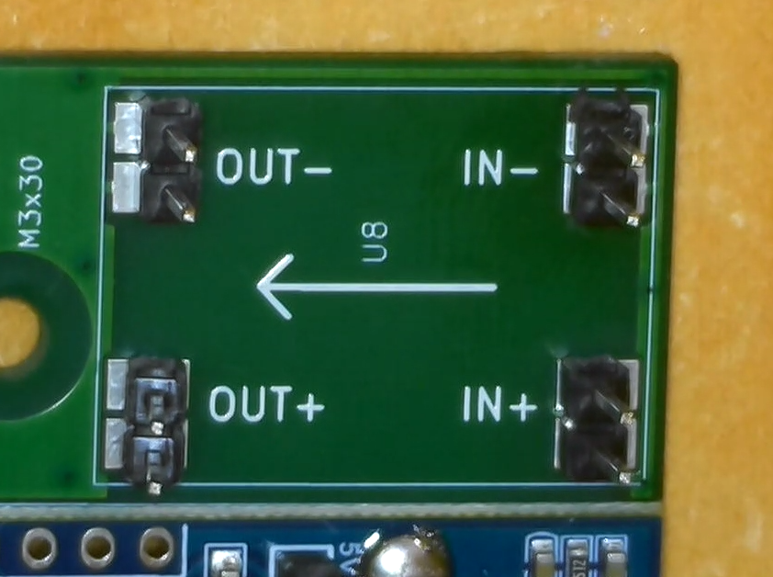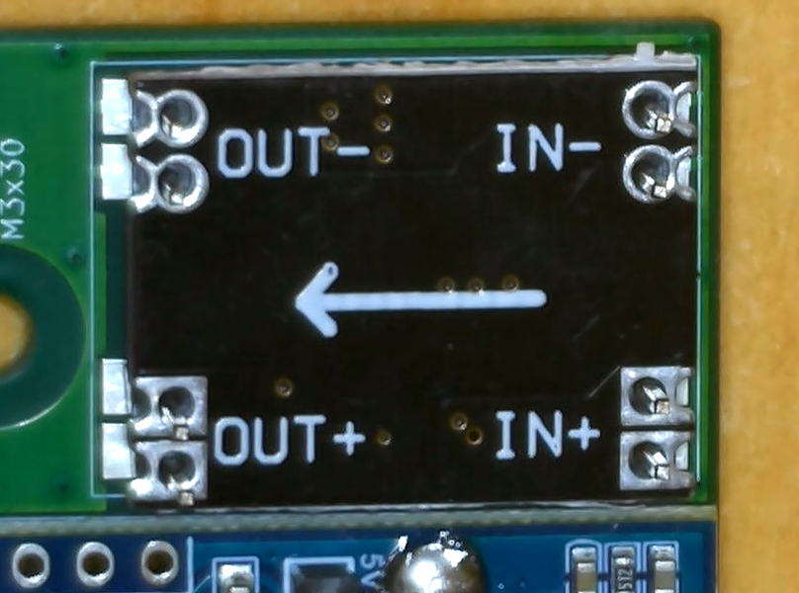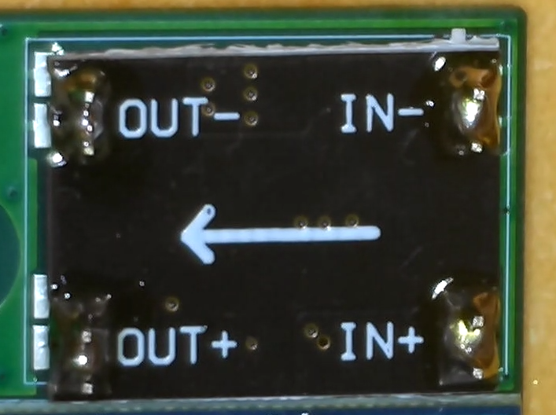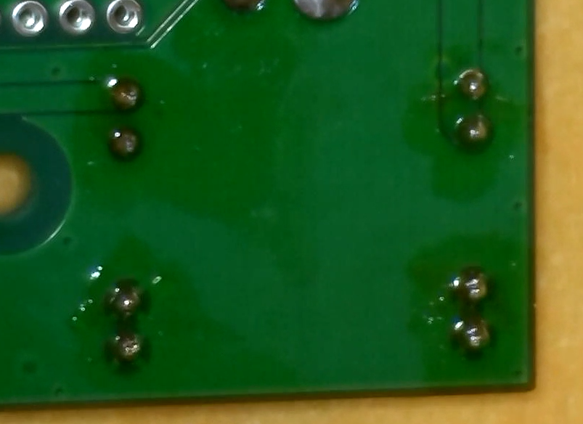

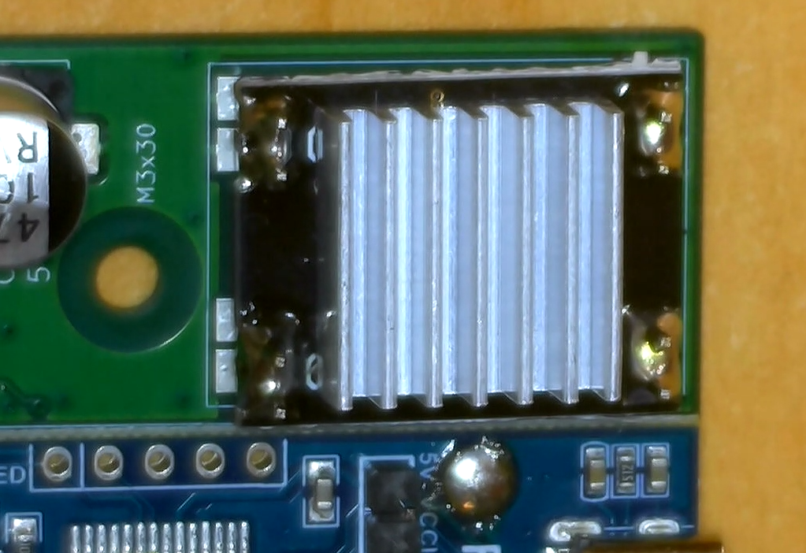Place the heatsink oriented as below

**DCDC converter Variant B:** Use the 5 position pin header to solder the Pololu D36V28F5 converter in its place. Chose orientation to match the white outline on the PCB. The heatsink is not needed.

Solder the fan connector

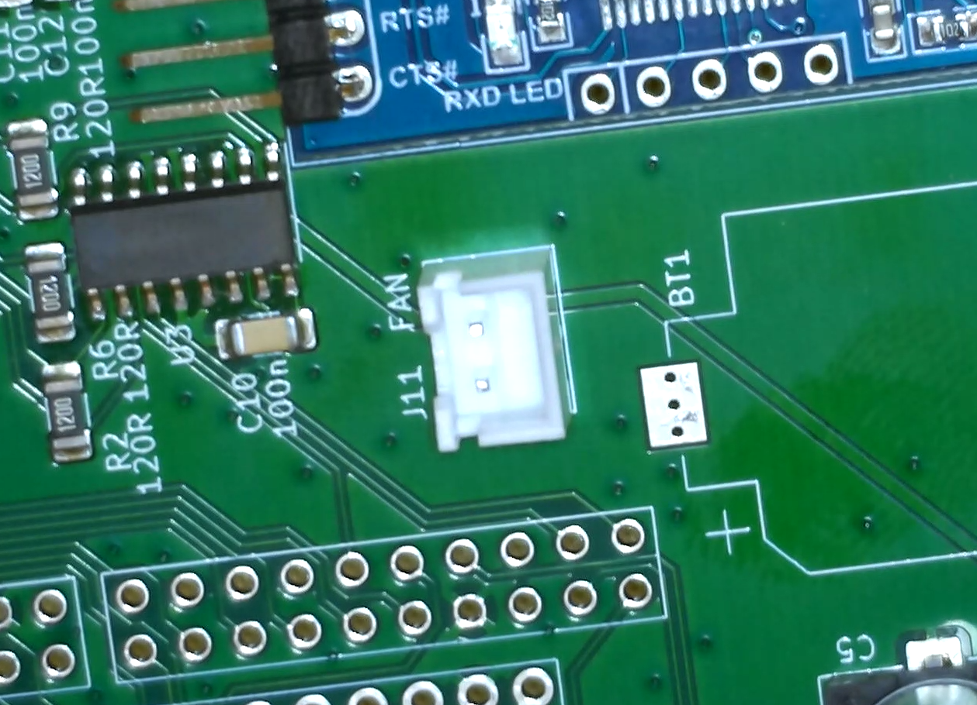

Solder the DC jack connector

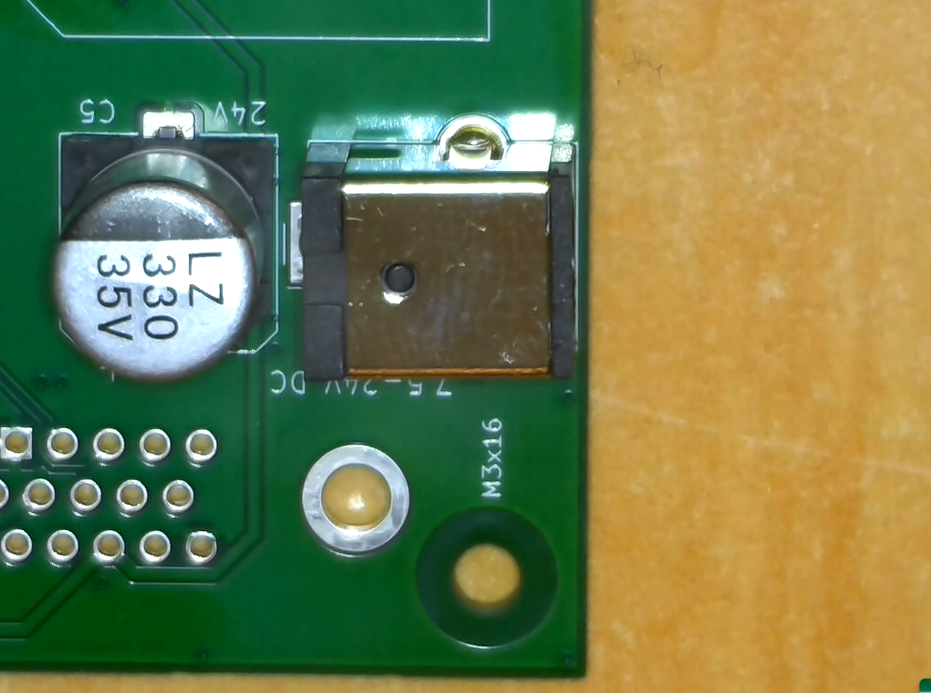

Solder the stepper motor driver headers. Use two long 24 pin headers and three 2-pin headers. You may use the driver board to hold the headers in place during soldering.

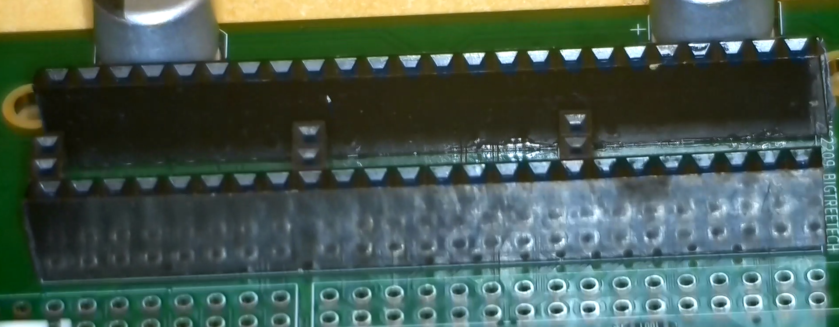

Solder four two-row pin headers for nucleo board. They should be on the **bottom side** of the board

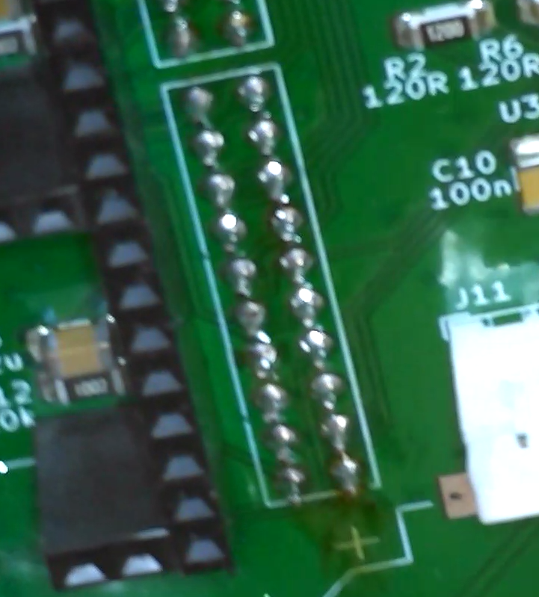

Populate the motor connectors **on the bootom side** of the PCB

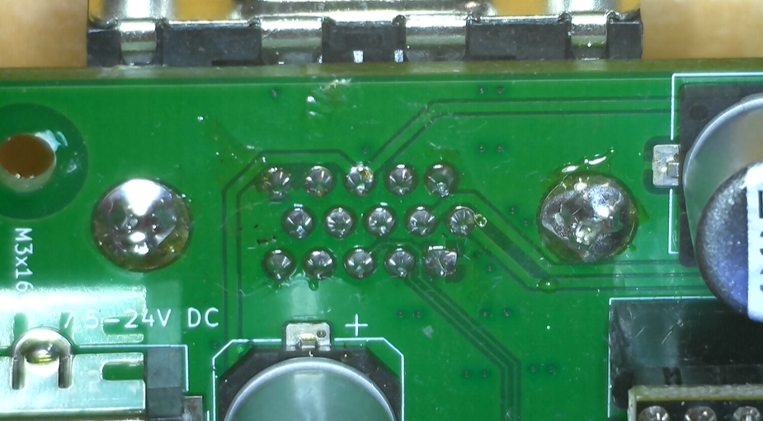

Solder the three encoder connectors on the top side 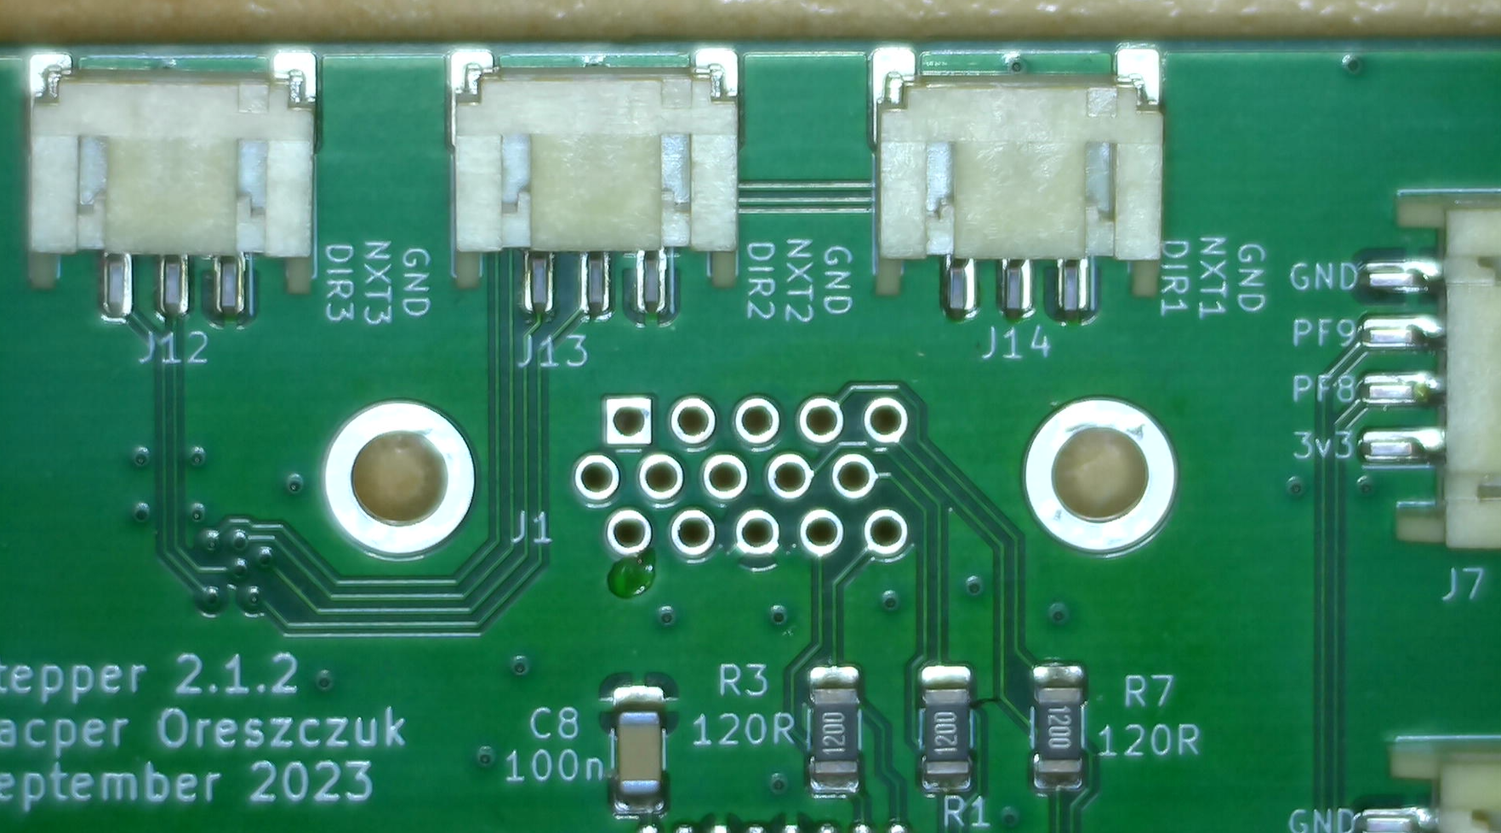

Solder the coin battery holder

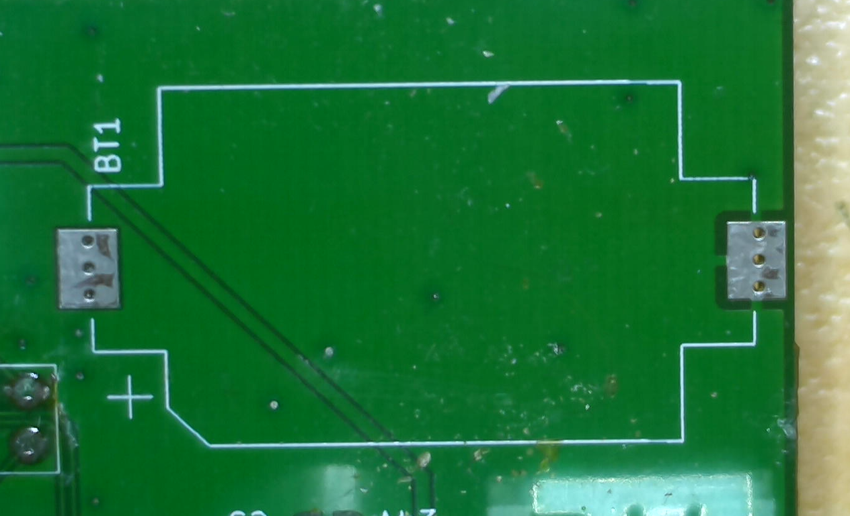

Cut the three longer pins on top of the TMC2226 motor drivers

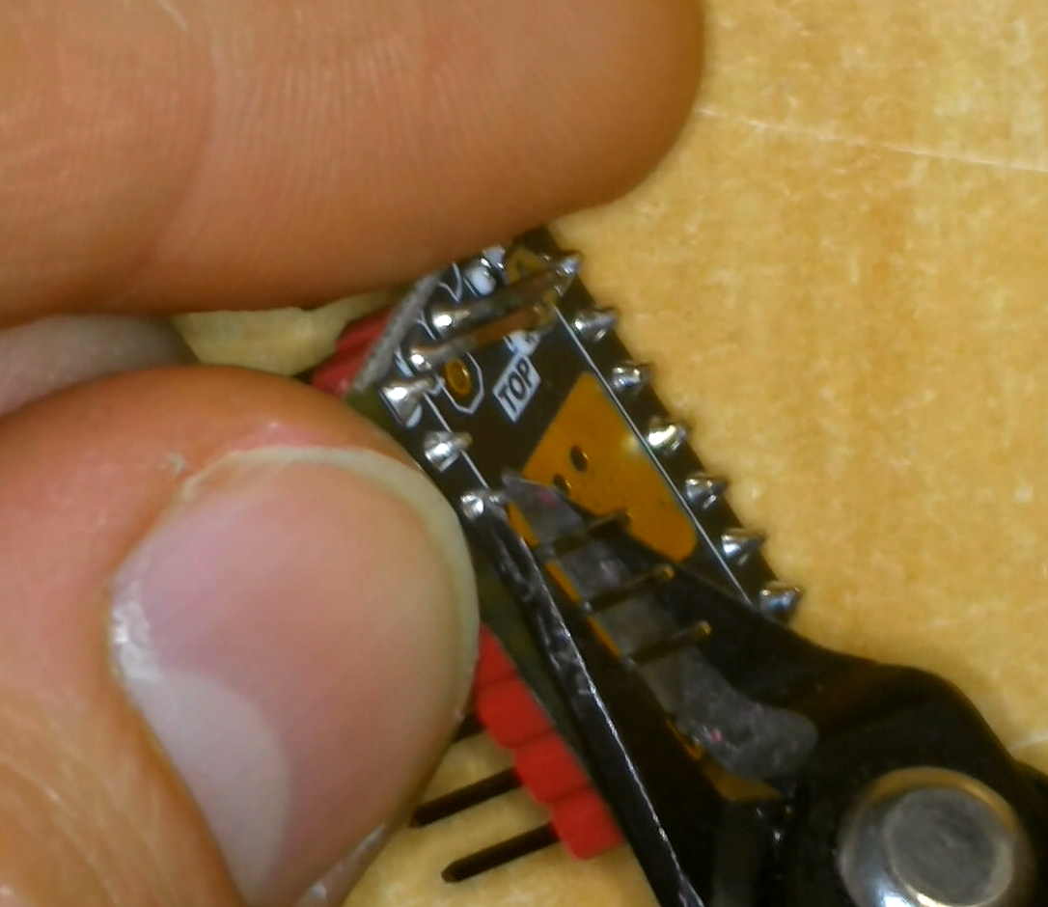

Unsolder the potentiometer from the driver board. Use a blob of solder, try to wet pair of pads on the edge of the board and warm the top of the potentiometer. 400°C is fine.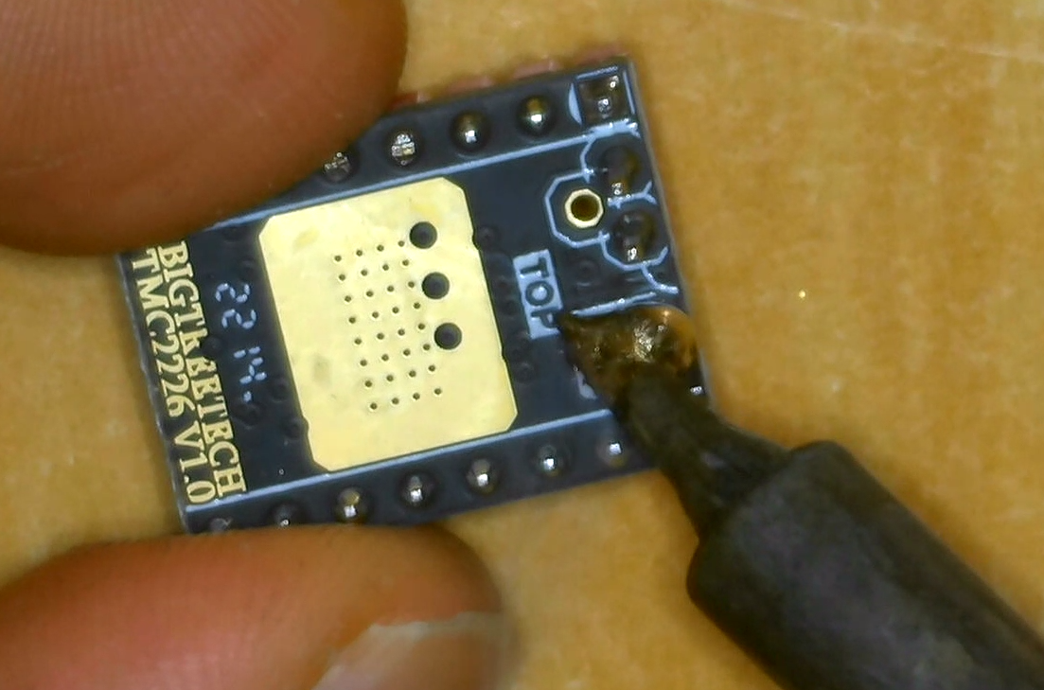

Place the large heatsinks on top of the drivers and insert them onto the PCB. Take care not to touch the pins with the heatsink.

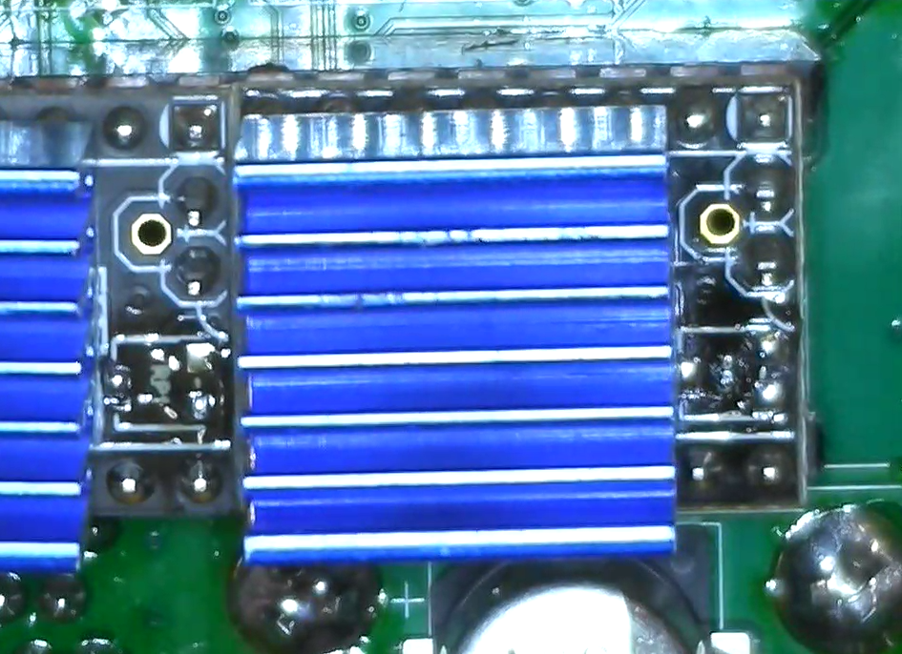

Solder the 2-pin header on the nucleo board as below:

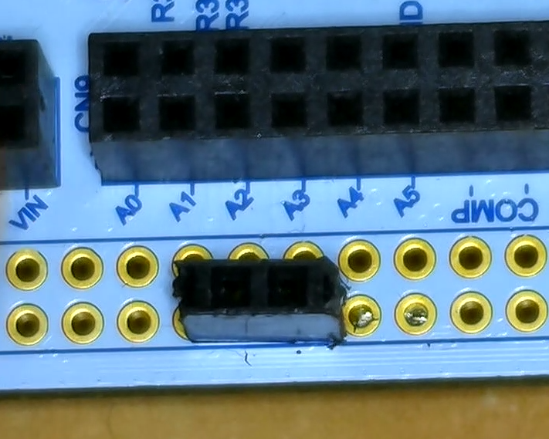

Solder the corresponding pin header on the PCB:

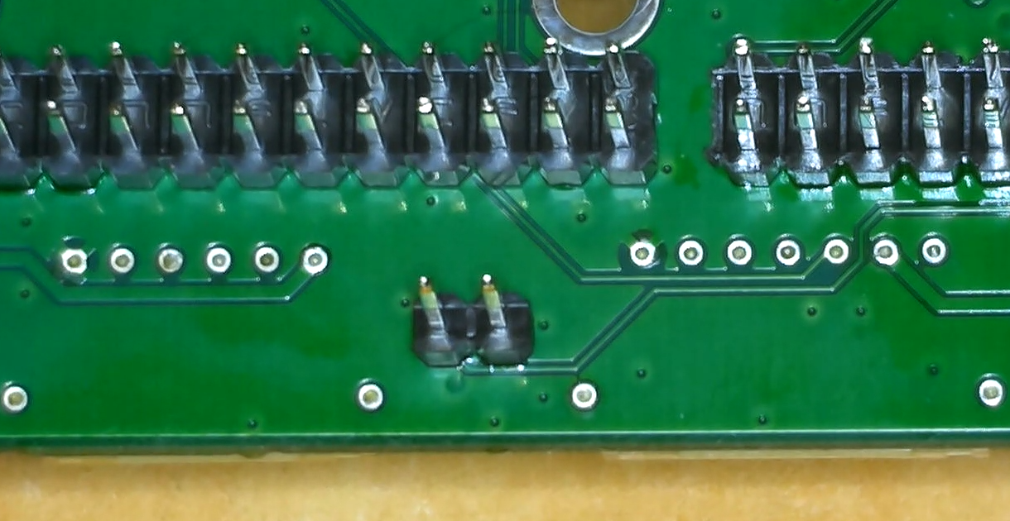

Unsolder the SB52 solder bridge

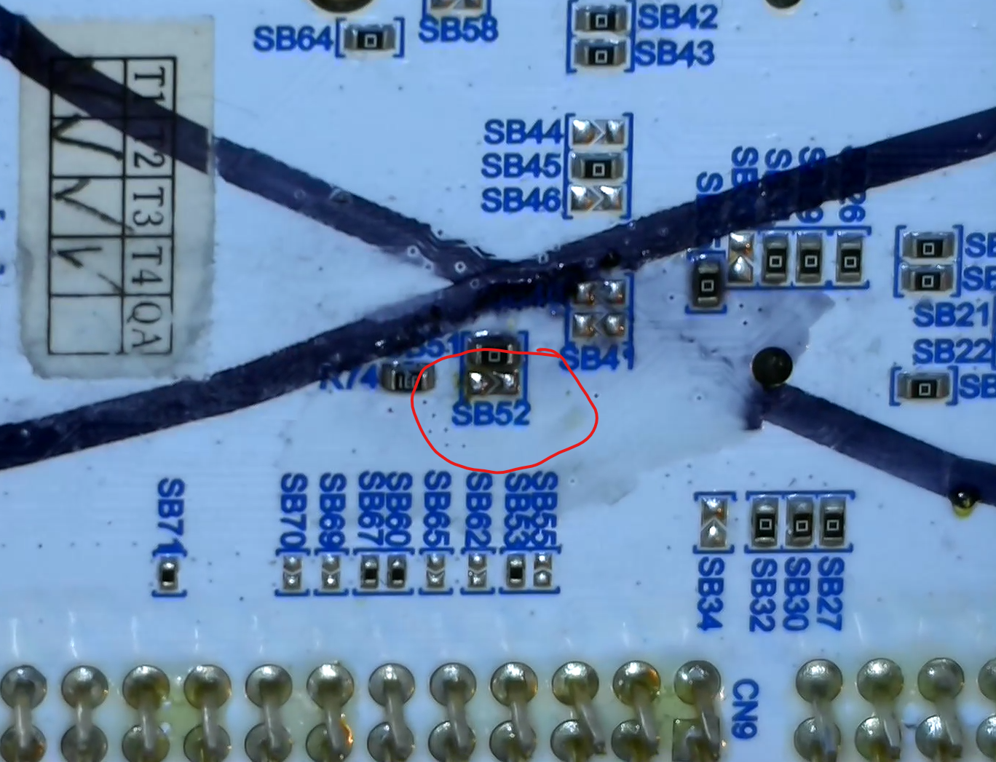

Move the jumper to EXT 